

The University of Edinburgh

School of Mathematics

**Topics in Applied Operational Research**

Instructor: Professor Miguel Anjos

Group members:

Siyu Wang (s1920930)

Sijing Wu (s1994311)

Shuai Pan (s1925253)

DATE: 27/02/2020

**1 General Introduction**

**1.1 Background**

Webb Wheel (WW) is an auto parts manufacture, which receives new orders from customers each day. Considering sufficient inventory, WW combines these orders into loads daily, and releases them based on different dispatch criteria. For outbound shipments, WW has two delivery options, truckloads and containers. The main goal is to help the company decide the amount of customer orders shipping at both plants. And one of secondary goals is to characterize and evaluate load-dispatch polices. The main challenge, however, is dynamically changing and incomplete demand information. The research team has designed an integrated model to simultaneously optimize the loading and routing decisions. And the optimization model is divided into assignment sub-problem and routing sub-problem.

**1.2 Transportation Mode Characteristics**

WW relies on common carriers that use TL and IM policies to fulfil customer orders. The more detailed specifics for these transportation modes are as follow:

1. Truckload (TL) Characteristics

The cost of a TL route is based on the distance travelled, the mileage rate and the number of drops on the route. Therefore, the total cost is determined in one of two ways: If minimum charge is met or if minimum charge is not met. Besides, we need to pay attention that the capacity of the trucks is limited and the mileage rate of the final drop location.

1. Intermodal (IM) Characteristics

This mode is cost saving as first load the order onto a container and then transport to a ramp; after that, the container is loaded onto another truck for delivery. There are two main costs: a drop charge per order and a ramp location-based fixed cost. We need to pay attention that the capacity of the trucks and total service time limits.

**1.3 Dispatch Policies**

To determine which routes to dispatch, we evaluate two policies: truck-utilization and route utilization. TU is calculated the ratio of total weight on the truck to its capacity. This policy has been implemented widely because of its understandability. However, RU is intended to facilitate order consolidation from similar locations, so such policy can achieve high utilization throughout a route.

**2 Assignment Sub-problem Model**

The assignment sub-problem determines the choices of transportation mode and carrier, while considering the total transportation cost.

**2.1 Modelling Considerations**

Current practice of WW is that the planner selects the farthest open order from the factory as benchmark, and then manually adds other orders to the path until maximum capacity is reached. Using the algorithm, we will consider the TU rate and RU rate at the same time. In order to optimize the problem, we divide the overall problem into two sub-problems.

**2.2 Data Generating**

To generate the location of order, plant and seed, we make some assumptions:

(1) We used Ningbo city in Zhejiang province as the reference city. It is relatively squared, and the area is about 10000 $km^{2}$.

(2) We divided the total area into three main districts. Then, we assume that the order location follows Gaussian distribution in each district.

(3) The paper shows that the order number in four months is about 2300. Therefore, we set the order number to 100 per week.

(4) The plant is set up in remote suburbs of the city because of lower costs. So, we set the plant at coordinate (10, 10) in the figure 1.

(5) The seed locations and container locations are selected based on the order distribution and the distance between order locations and plant location. Since containers use train and can reduce the cost, we set each container location at the center of the two further districts.

(6) We assume that one seed location can serve only 20 customers. Therefore, we set the four seed locations and two container locations respectively.

To generate the order location, firstly, we chose three points, which represent the most popular districts. Then we add 10 times Gaussian noise to these three points. We also assume the point that is closest to the plant has more customers than other two points. Therefore, we generate 40 points to the closest point and 30 points to other 2 points separately. The figure of seed, plant and order locations can be seen below.

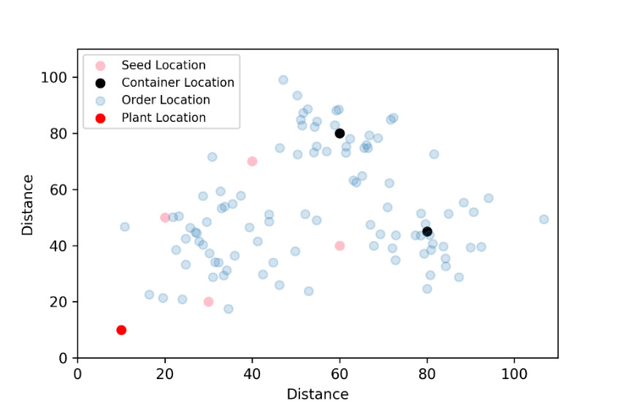

Fig 1. Scatter plot of seed location, order location and plant location

From this dataset, we calculated $d_{ij}$ the distance between seed locations to order locations, $d_{0j}$ the distance between plant to seed locations, and $d_{0j}$ the distance between plant and order location.

Other parameters selection is based on paper. We set rate per mile equal to 2.31 which is used by author. From the equation of Truck-Seed Location Cost, we can get that the surcharge rate is a little higher than rate per mile. Therefore, we set the surcharge rate to 3 and minimum charge by company to 1500. According to the equation of TU that the total weight of each product deliver to each order need to be less than the capacity of seed location times truck load rate, we get the weight of products between 15 and 25 and the demand of each product from seed location to order location randomly between 1 and 10. The capacity of each seed location is 43500 pound which is also used by author ,and the inventory of each product is set randomly between 0 and 6000 because sometimes the inventory might be run out. In order to mimic critical order, we assume the critical order follows binomial distribution with n = 100 and p = 0.1. Based on our empirical knowledge, we set drop charge to 10, drop time to 10 minutes, average speed to 1.5km/min, and available container driving time to 440 minutes.

**2.3 Model Discussions**

The objective function is to minimize the sum of setup and assignment costs without violating any of the location-related constraints. And we define seed sets for each transportation mode. Our model includes TL and IM polices. Then we calculate Truck-seed location costs according to the truck cost structure in the appendix.

Decision Variables: the model has introduced three sets of decision variables. The first shows the setting of the seed location and checks whether it is used; the second is to assign customer orders to seed location; and the last one represents the quantity of products delivered to a customer via a selected seed location.

Constraints: Constraints (1) ensure that the capacity of a seed is not exceeded by weight-based products p shipped under any circumstances. Constraints (2) and constraints (3) state that the total amount of shipment through two transportation modes for a chosen product for a customer order is supposed to be less than the demand of orders and available inventory respectively. Constraints (4) ensure that satisfying the demand for critical customer orders has been given priority when WW is confronted with inventory shortcomings. Constraints (5) state the amount of product *p* shipped for order *j* via seed location *i* need to equal or greater than the minimum between the sum of the demand and inventory, so order can be satisfied as much as possible. We use the star-distance approximation to estimate the total travel time of the loads and determine whether use this container seed. Constraint (6) ensure the sum of time spent during the delivery is less than or equal to the total service time, which means the order can be assigned to the container seed locations if this constrain holds.

Actual route Star-distance approximation

Fig 2. Star-distance approximation

Constraint (7) and (8) present the relationship among decision variables.

**2.4 Results Discussion**

First, we assume that the truck utilization can be used at most 100% and check the results.

|  |  |  |  |  |
| --- | --- | --- | --- | --- |
| Seed Location | Truck Utilization | Total Shipment | Total Cost(dollars) | Cost per pound |
| 1 | 0 | 84731 | 6228.17 | 0.0735 |
| 2 | 0 |
| 3 | 94.78 |
| 4 | 100 |
| Container Location | Truck Utilization | Total Shipment | Total Cost(dollars) | Cost per pound |
| 5 | 71.98 | 60317 | 5175.23 | 0.0858 |
| 6 | 66.68 |

Table 1. Results of at most 100% TU Rate

The total cost is 11403.4 dollars, and cost per pound is 0.0797 dollars. Both container locations are used though the truck utilization is relatively low.

Then, we also check the results when the maximum truck utilization can only reach to 80%.

|  |  |  |  |  |
| --- | --- | --- | --- | --- |
| Seed Location | Truck Utilization | Total Shipment | Total Cost(dollars) | Cost per pound |
| 1 | 0 | 69600 | 6640.37 | 0.0954 |
| 2 | 0 |
| 3 | 80.00 |
| 4 | 80.00 |
| Container Location | Truck Utilization | Total Shipment | Total Cost(dollars) | Cost per pound |
| 5 | 72.49 | 62807 | 4982.09 | 0.0793 |
| 6 | 72.49 |

Table 2. Results of at most 80% TU Rate

From Table 2,we can see the total cost is 11622.46 dollars with 0.0875 dollars per pound. Obviously, the cost per pound increase due to the limitation of utilization. As we limit TU rate at most 80%, seed location 3 and 4 reach the maximum and the TU rate of container location 4 and 5 increase as well, compared with Table 1. Moreover, we can find seed location 1 and 2 are useless which means the cost of these two seed location is expensive than other fours. Nevertheless, they could be used to expand the customer base. This is another issue we will consider in the future.

Fig 3. The Cost Per Pound of TU and RU Dispatch Policy

From Fig 3, we compare the cost per pound at different TU rate of 80%, 85%, 90%, and 95%, which means the most TU rate it can reach. There is a dramatically decrease when the most TU rate reaches 95%, and it saves around 0.0094 dollars compared with at most 80% TU rate.

In the next step, we calculate the cost per pound based on different RU rate. Compared with TU, it can be easily to see that choosing RU policy is cost saving. Even with the lowest RU rate of 80 percent, the value of cost per pound is approximately lower than the best cost per pound returned by TU.

**3. Summary**

The assignment sub-problem model is based on truckload and intermodal characteristics. We assume there are three main districts in the city and plant is set in the suburb. Then we set four seed locations which are relatively close to the plant and two container seed locations which are in the centre of the far districts. Then calculate the TU and RU at most 80%, 85%, 90% and 95% rate respectively to compare the cost per pound. It concludes RU is more cost-saving than TU in general. When RU and TU reach 90% or above, it is more efficient. The drawback of the assignment sub-problem model is that when we maximum the RU rate at 90%, TU rate is over 100% which is impossible in real world. Therefore, in the next stage we will try to use routing sub-problem model to optimize the whole model.

**Appendix**

Truck-Seed Location Cost

$$c_{i}=\left\{\begin{aligned}d_{0}sr+mc , ifd_{0i,}≤mc \\ \left(sr+r_{i}\right)d_{0i,} otherwise\end{aligned}\right.$$

Assignment Cost to a Truck Seed

$$a_{ij}=\left\{\begin{aligned}dct+\left(d_{0j+}d_{ji}\right)sr+mc-c_{i, }if\left(d_{0i+}d_{ji}\right)r_{i}≤mc \\ dct+\left(d_{0j+}d_{ji}\right)\left(sr+r_{i}\right)-c_{i}, otherwise\end{aligned}\right.$$

Weight-based Truck Utilization (TU)

$$TU_{i}=\frac{\sum_{j∈F}{\sum_{p∈P}{w_{p}X_{ijp}}}}{Q_{i}} × 100$$

Route-Based Utilization (RU)

$$RU_{i}=\frac{\sum_{j∈F}{\sum_{p∈P}{d_{0j}\left(w_{p}X_{ijp}\right)}}}{L_{i}Q_{i}} × 100$$

Objective Function of Assignment Problem

$$\min\left\{\sum_{i}{c_{i}γ_{i}+\sum_{i}{\sum_{j}{a_{ij}z_{ij}}}}\right\}$$

Constraints



$\sum_{jϵF}{\sum_{pϵP}{w_{p}}}X_{ijp}≤{TU*Q}_{i}, ∀i ϵ{ F}^{’}∪F^{’’}$

$\sum_{iϵF}{X_{ijp}}≤D_{jp}, ∀j ϵ F and p ϵ P$

$\sum_{iϵF}{\sum_{jϵf}{X_{ijp}}}≤ I_{p} , ∀p ϵ P$

$\sum_{iϵF}{\sum_{jϵf}{X_{ijp}}}K_{j}≥min\left(\sum_{j}{D_{jp}}K_{j} ,I_{p}\right), ∀p ϵ P$

$\sum_{iϵF}{\sum_{jϵf}{X_{ijp}}}≥min\left(\sum_{j}{D_{jp}} ,I_{p}\right), ∀p ϵ P$

$\sum_{iϵF}{\left(DT+2\frac{d_{ij}}{v}\right)Z_{ij}≤HL, ∀i ϵ F^{’’}}$

$\sum_{iϵF}{X_{ijp}≤\sum_{pϵP}{D_{jp}}}$

$Z_{ij}≤Y_{i} ,$ $∀i ϵ F and j ϵ F$

$X_{ijp}ϵZ^{+}, Y_{i} and Z_{ij} ϵ \left\{0,1\right\} , ∀i ϵ F ,j ϵ F and p ϵ P$

Decision Variables

1. : *is_binary*: 1 if order j assigned to seed location I else 0

2. : *is_binary*: 1 if seed location j is created for order I else 0

3. : *is_binary*: 1 if seed location I is used else 0

Parameters

1. sr: Surcharge Rate

2. $d_{oi}$: The distance between plant to seed location *i*

3: mc: Minimum charge by company

4: $r_{i}$: Rate per mile for seed location *i*

5: $d_{ct}$: Drop charge

6: $d_{ij}$: Distance from order location *j* to seed location *i*

7. $w_{p}$: weight of product *p*

8. $X_{ijp}$: amount of product p shipped for order j via seed location *I*

9. : (assume all capacity is same) capacity of seed location *i*

10. : Demand of product *p* in order *j*

11. : Available inventory of product *p*

12. : *is_binary*: 1if order is critical else 0

13. HL: Total available driving time

14. DT: Drop time of an order

15. : distance between seed location I and order location j

16. v:average speed

**Reference**

Anon, 2014. An Integrated Load-Planning Algorithm for Outbound Logistics at Webb Wheel. *Interfaces*, 44(5), pp.480–497.